1. Setting up the development environment
   1. Install a Visual Code
   2. Install Android studio
      1. Une image contenant texte

         Description générée automatiquementClick on virtual device manager
      2. 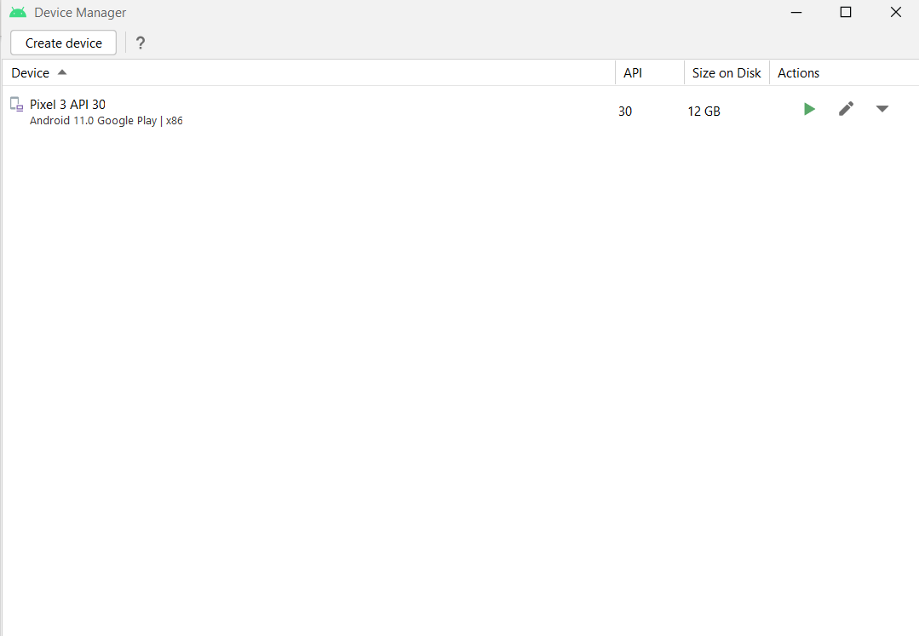Either create a new device or launch the emulator if already created
   3. Download Node.js (<https://nodejs.org/en/download/> )
   4. React Native: The easiest way to get started is with Expo CLI
      1. npm install -g expo-cli
      2. To start a new React Native App, you use: expo init NewProj
      3. Then you run the application with npm start
      4. To install any package to use with react native:

npm install package_name

1. Navigation:

* **AppNav:**

If UserToken exists, open AppStack

Else Open Auth Stack

* APP Stack: